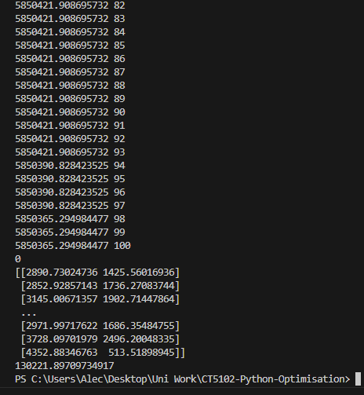

Best results:

After performing 10000 iterations of my simulated annealing algorithm.

I got a best distance of 5850365.294984477

And this whole process took the program 130221 seconds to run.